**COMP 122 Intro to Assembly Programming Spring 2021**

**Student: Joshua Cohen Instructor: Dr. Jeff Drobman**

**Lab #: 4 Software Interrupts** LAB FORM

Requirements 

1. Decode Pending Interrupts

2. Allocate memory for Handlers

3. Use Jump Table

1. Order by Priority
2. Test and Jump
3. Handlers as subroutines: jal -> jr $ra

Inputs

*paste here screenshots of all inputs (not code): .data segment & GUI/console*

Data Segment: (Hexadecimal Addresses)

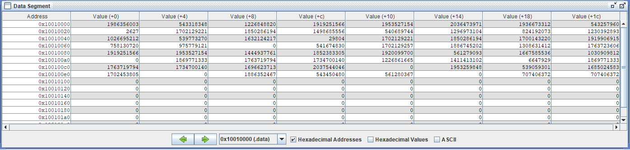

(ASCII):

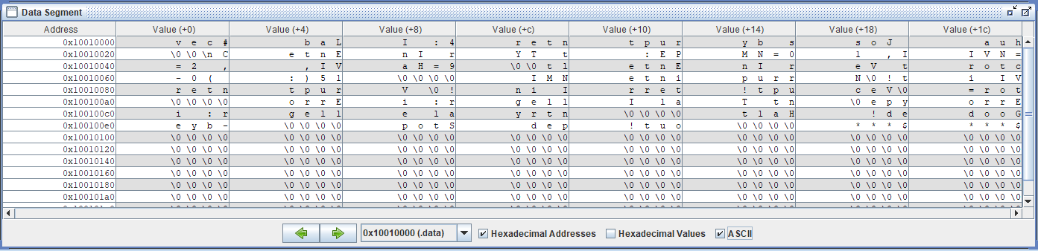

Outputs (note: you must execute the code to get outputs)

*paste here screenshots of all outputs (not code): console/GUI, .data, .heap, registers*

Input GUI msg:

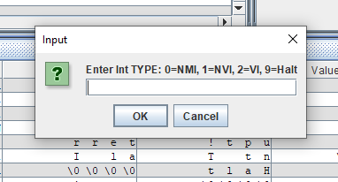

NMI interrupt: (GUI)

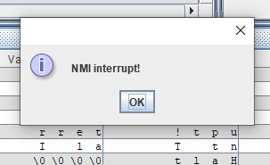

(Console):

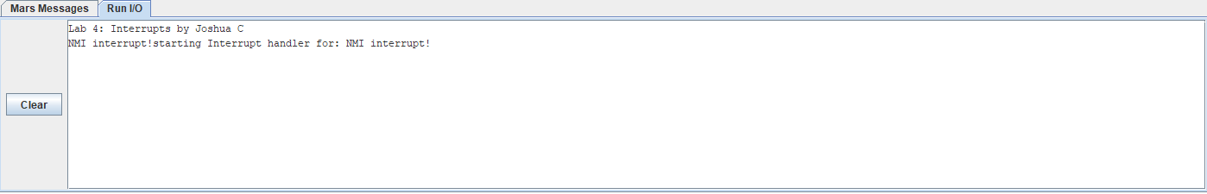

NVI interrupt: (GUI)

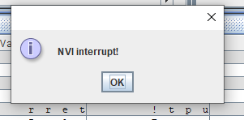

(Console):

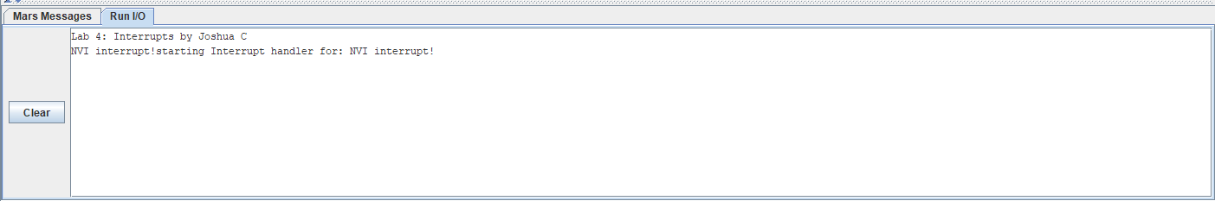

VI Vector Interrupt:

Console Vectors Outputs (V0-V3):

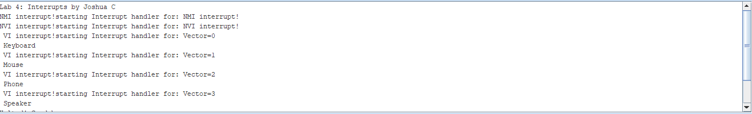

Halt:

Console & GUI Halt msg:

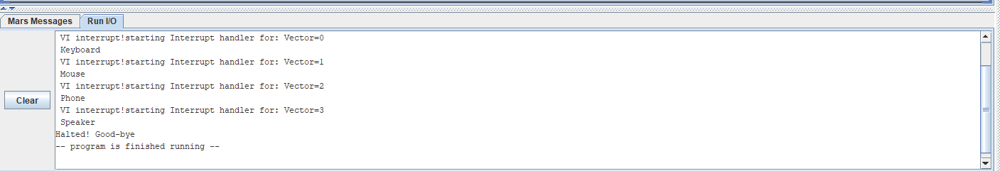

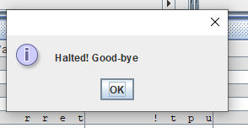

Data Segment (Output) ASCII:

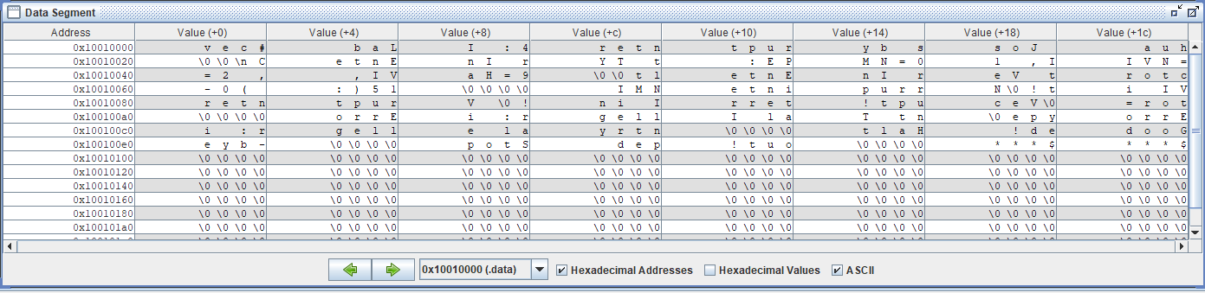

Skip to next page for source code

|

\ | /

\ | /

\|/

Process (algorithms): *source code*

*(paste original syntax colored view here; include line numbers – make legible)*

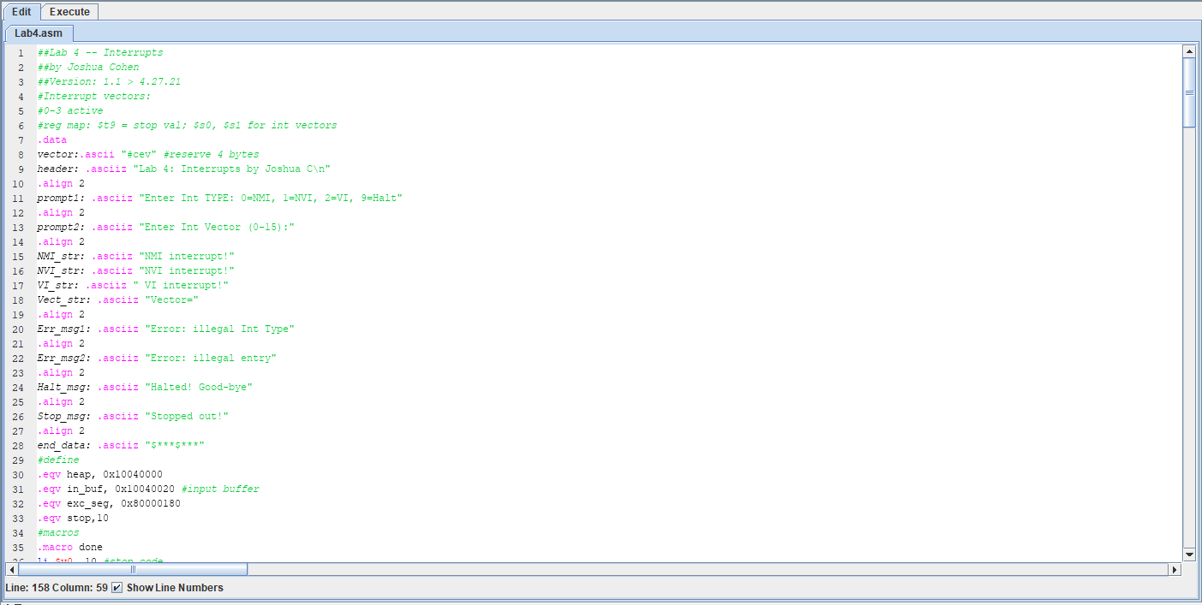

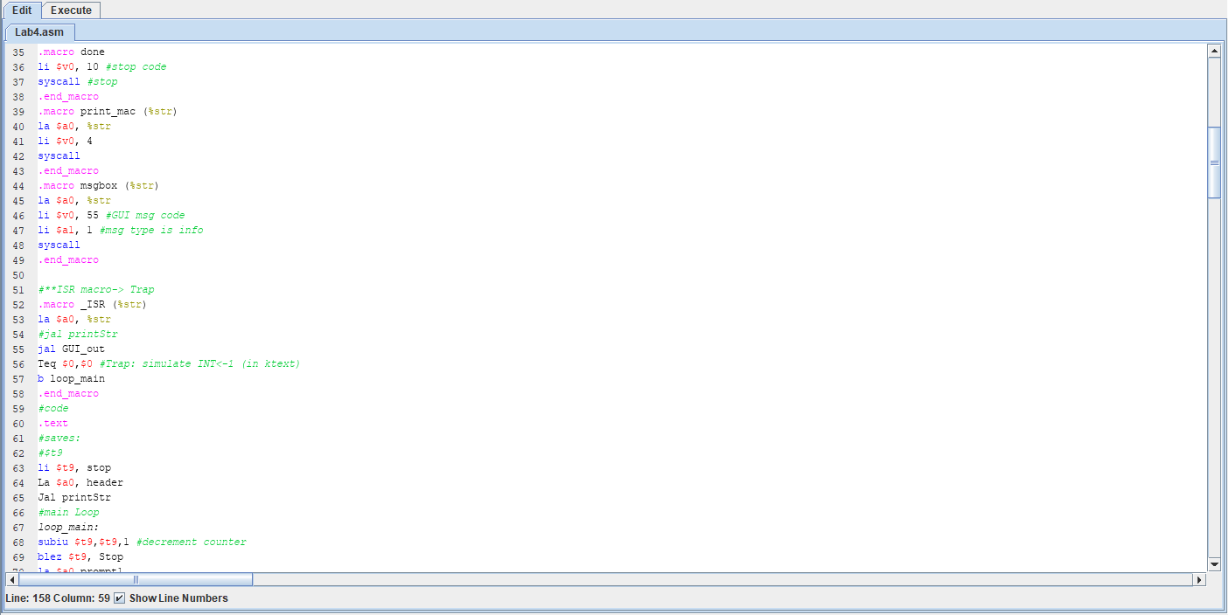

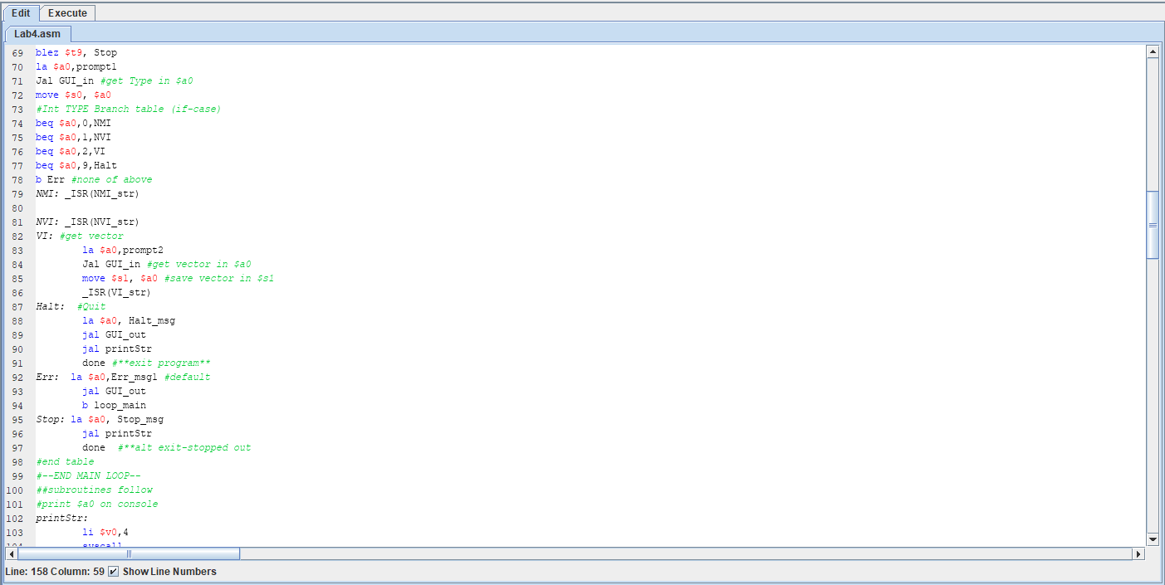

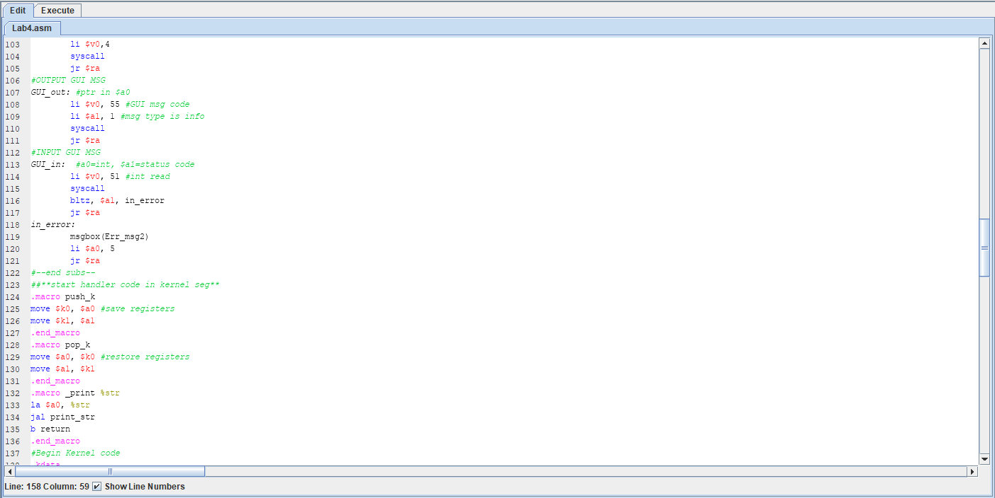

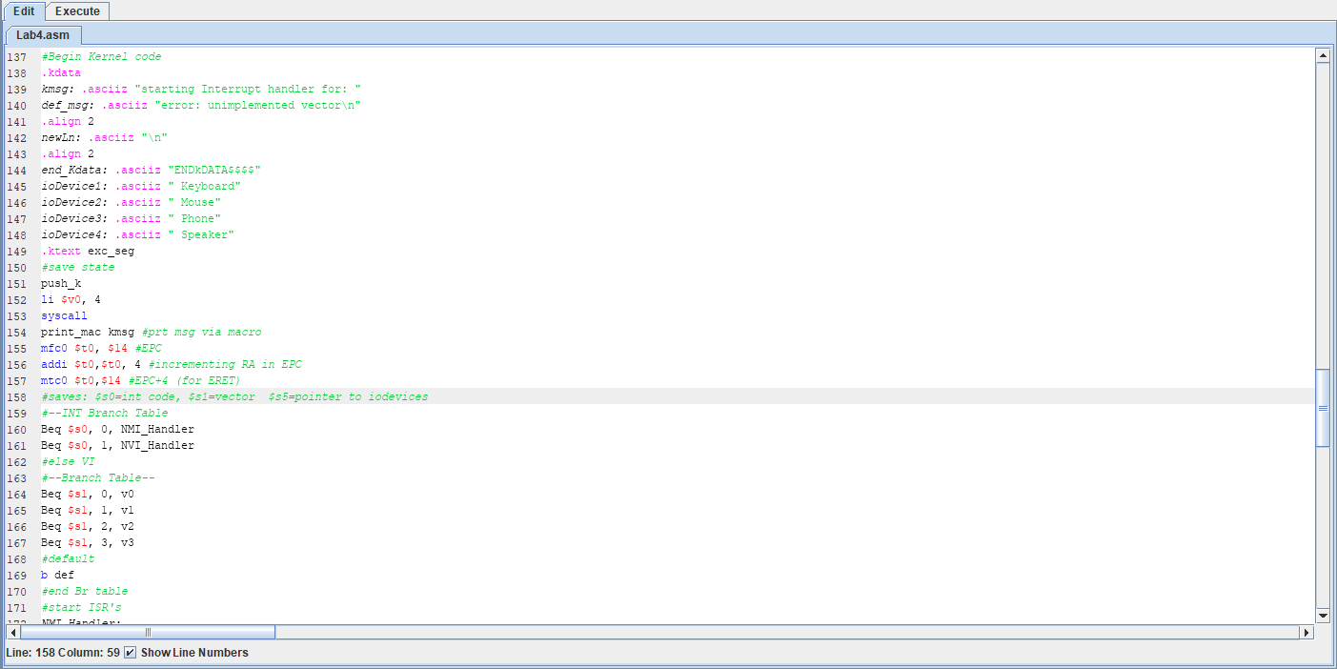

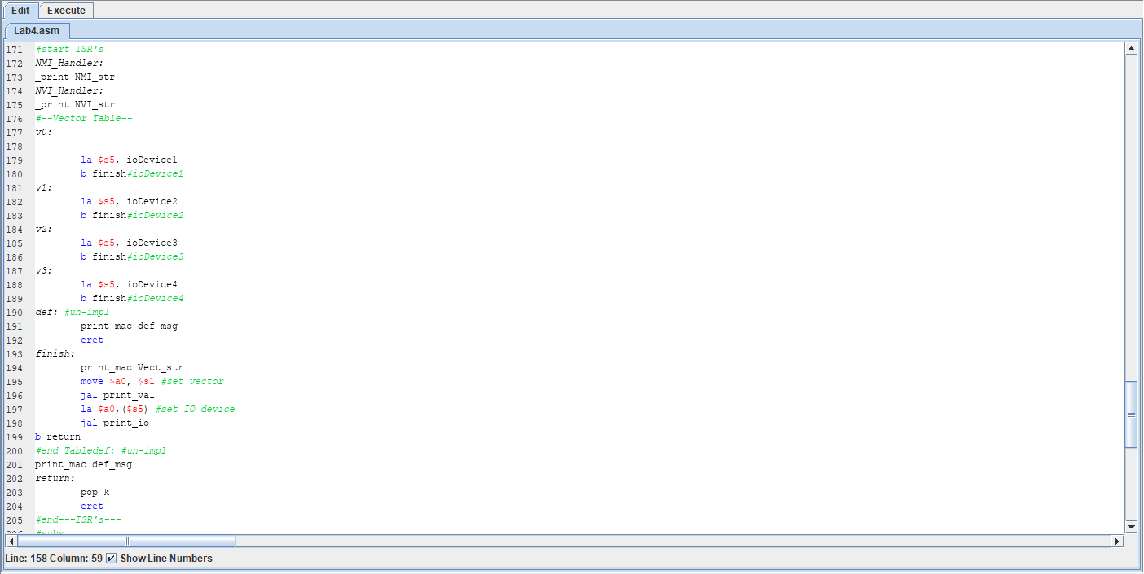

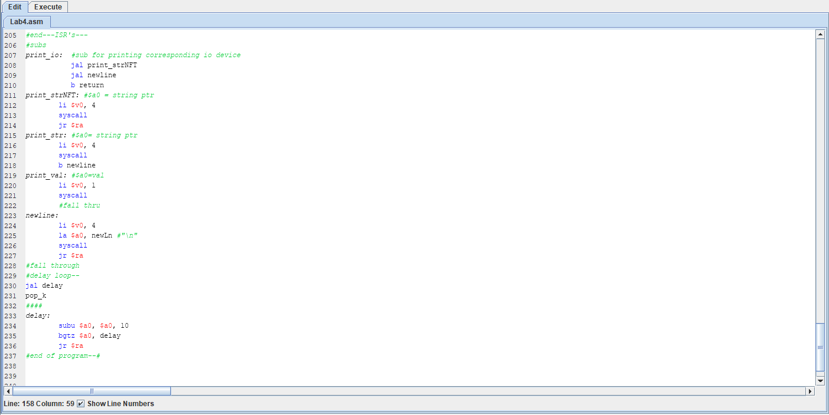

(END of Source Code)